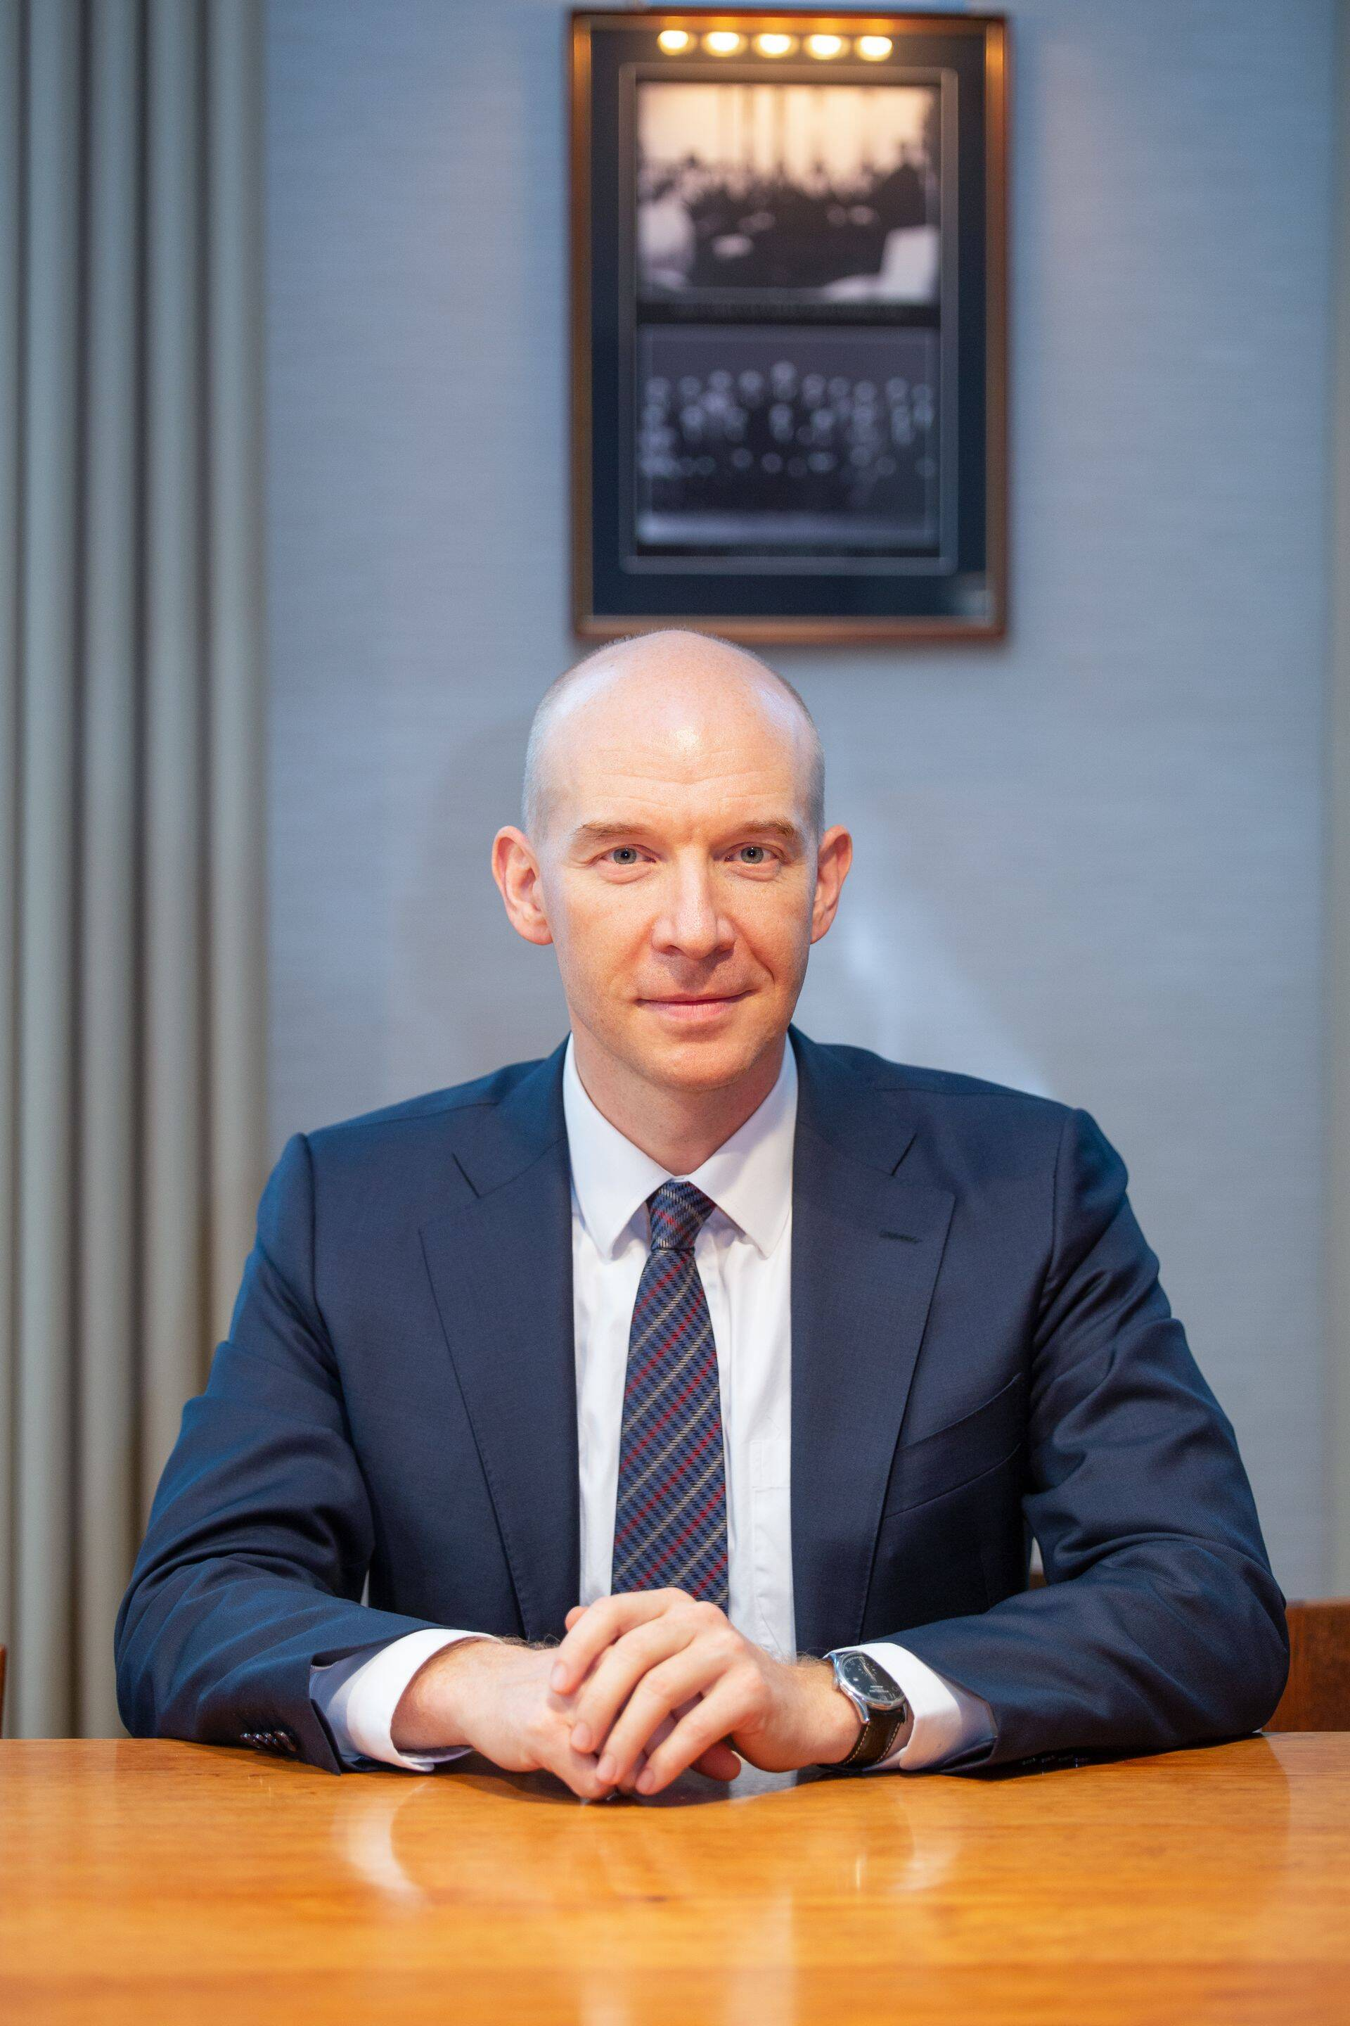

Madis Müller is an Estonian economist who served as the Governor of the Bank of Estonia (Eesti Pank) and as a member of the Governing Council of the European Central Bank from 2019 until June 2026.

Mr Müller will join the Fiscal Council because council member Ülo Kaasik decided to step down from his position after he assumed the post of Governor of the central bank. Madis Müller served as Governor of Eesti Pank in 2019-2026 and was Deputy Governor prior to that from 2011. The composition of the Fiscal Council will now be Chair Peter Lõhmus, Vice-Chair Viljar Arakas and members Karin Jõeveer, Robert Kitt, Martti Randveer and Madis Müller.

